introduction to Data mining

University of the Cumberlands – SUMMER 2018

Week# - 6

**Name:**

**V M Naveen Chatlapalli (002836193)**

**Sai Charan Dasari (002843892)**

**Suhas Tadakamadla (002838126)**

**Class #: ITS632 - Data Mining**

**Professor: Liu, Ying Nathan**

**Date: 06/17/2018**

Contents

Supply chain Management 3

Plan 3

Develop 3

Make 3

Deliver 3

Return 3

Key Features of the Supply Chain: 4

Inventory Management 4

Order Management 4

Procurement 4

Logistics 4

Return Management 4

Supply Chain KPI 4

Transportation: 5

Inventory focus 6

Data mining Approaches used in the organization 6

Retailers 7

Distributors 7

Manufacturers 7

Identifying the KPI’s using the Datamining Approach 8

Conclusion 13

References 14

# Supply chain Management

SCM is a dynamic administration of Supply chain activities to expand client advantage and accomplish a practical competitive advantage. It speaks to a best effort put in by the supply chain firms to create and run supply chains in the best and proficient ways that could be available. They include/ cover almost everything including the Product improvement, Marketing or sourcing, Creation, Logistics and additionally the data frameworks expected to arrange these exercises. In order to convert a raw component into a final end user product, below are 5 basic components which are followed by the Supply Chain industries.

* Plan
* Develop(Source)
* Make
* Deliver
* Return

Plan: This is the first stage and a key part of Supply Chain Management where we create a basic layout or a strategy is developed on how the administration will address the issues of the clients. [1]

Develop: In this stage one gets a chance to build a strong relation with the dealers of the raw materials which are essentially used in the production. This stage also includes in strategizing methods like shipping, delivery, and payment. [1]

Make: At this stage, the item is being produced, verified, packed and scheduled for a delivery. This stage is always metric-centered as the organizations are given a chance to evaluate the quality of the product, Creation and productivity. [1]

Deliver: This is the stage where we get all the customer’s orders and then the delivery of the products are planned accordingly. This stage is often referred as Logistics by the Supply chain industries. [1]

Return: This is the stage where customers get a chance to return all the inadequate items or fault pieces and the organizations will address all the client inquiries. This can also be risky to most of the organizations as they need to develop a responsive and adaptable system for accepting imperfect and overabundance items. [1]

## Key Features of the Supply Chain:

Inventory Management: With Supply Chain, organizations can altogether enhance the way they track and deal with their provisions of crude materials and segments required for creation, completed merchandise to satisfy open sales order required for field administration and support.

Order Management: Supply chain can significantly quicken the execution of the whole order to delivery cycle by providing a helping hand to the organizations to and yield their productivity and increase their sales orders. [2]

Procurement: Using the supply chain software we can quantify all the assessments and assignments which are related to the marketing, obtaining and account payables. Hence, they can increase the arbitration and other cost-cutting methods. [2]

Logistics: This is one of the important features in the Supply chain management because as the organization. Starts to increase its productivity and grows its size, Supply chain becomes more hard and complex to handle all the Warehouses and transportation methods without its software. Using the SCM end result can increase like the productivity and the product delivery, which in turn yields to a better customer satisfaction. [2]

Return Management: Using the Supply chain software we can increase the automation process of the claims received from the consumers as well as the distributers. [2]

# Supply Chain KPI

While evaluating the wideness and cost of your stock system you should set up and screen KPIs which give detectable quality of cross utility activity and also those which apply to particular generation in arranging the required parts. Later in this article we'll look at a couple of instances of valuable and cross utilized (cross-practical) KPIs. Broadly, to be explained as it may be the involved with zones where those KPIs will be essential: [4]

* Capturing the Orders
* Managing the Inventory
* Costing and Supplier Management
* Producing of Commodities
* Warehouse Management
* Transportation

Cross practical KPIs are likely to provide snapshots of the following end-to-end performance factors:

* Order Supremacy (Maintaining the point of accuracy to which customers’ requirements are being met)
* Levels of Inventory
* Analysis of Stock Loss and Damage
* Profit in Gross
* Cost of the Sold Good
* Total Logistics Cost

Cross practical KPIs should be considered in such a way that each operation can see its contribution towards the overall supply chain performance. [4]

Logistics is a subset of Supply Chain management and in association of it we may place assets into advancement updating structures, it would be taking full flavored outlook of the data you presently have before you. KPIs are key in observing the inventory system's execution. KPI can tell if work is being done capably and efficiently by any team in the organization. [4]

Key KPIs and the favorable circumstances of any Supply chain management company are discussed below.

### Transportation:

Delivery Completion - shows the transporters ability to pass on successfully on time to their arranged required delivery date or to the course of shipment time. Having a correct on-time movement is essential for your client to avoid costs, as they may be obligated to charges from huge box retailers if the date is missed. In case, the report shows that 99% operations should pre-processed and look for consistent change and efficiencies.

Cost per Pounds - measures net cost of the shipment with signified weight moved each month/quarter to show the buying and utilization cases to customers. This KPI will empower your customer to continue purchasing any product they like. [5]

### Inventory focus

Stock Correctness - measures the precision of inventory focus on workers while arranging and managing their tasks. You require high accuracy to ensure the correct commodities are taking off to the correct customers. Low stock precision can make customer churn and make additional costs to settle orders.

Stock Available - measures the procedure span from the earliest starting point of a receipt to the time it is triggered. This is basic to track the efficiencies of inbound activities and to ensure your thing is available for orders as quick as possible, and could sensibly be normal. [5]

Deliver it on time - shows the level of shipments that left the stockroom/ ware house on-time. All things have critical movements with small time frame. If a shipment is missed, your client may be ended up with delays and late costs. [5]

Demand Forecast - shows the exactness of the shipping orders managed. Not solely to realize what number of shipments they can fill a hour, anyway what number of exact solicitations would they have the capacity to fill.

# Data mining Approaches used in the organization

Supply chain management system includes the management of products, information, and money. In standard organization, business frames are isolated from stock control and, subsequently, stock is the quick yield of missing information. The point of convergence of contemporary stock system organization is to deal with, design, and complete these streams. Data mining can make a subsequent match among free market movement, diminishing or occasionally despite taking out the products/ commodities. [5]

Data mining in positive manner has transformed into a fundamental need in observing needs, tendencies, and practices of customers. It is used as a piece of assessing, developing, and item change. Generally, data mining strategies have been used as a piece of dealing with a record, security, and retail business. This is for the most part an aftereffect of the way that the utilization of these procedures showed quick returns. Additionally, data mining is used as a piece of a combination of various organizations, for instance, the budgetary, human administrations, and media correspondences industry, among others. [1]

There are a lot of possibilities and usages of data mining is obvious in SCM industry. One of the potential zones is "Generation organize Management." One of the substances of the demand and supply in the gathering business is that paying little amount to how all around balanced a system is, among demand and supply. The objective of this article is to perceive those regions in the organizational system where most of the powerlessness exists and to choose suitable data mining procedures to exactly predict opportunities. [6]

#### Retailers:

The main advantage between the forecast and the actual consumption for the retailers is the variation in the demand. The difference between the request and the supply accounts for the difference in the supply. [4]

Data mining can be used at this point in the following ways:

* + Market segmentation based on organizational needs of distinct groups.
  + Market Analysis - retailers can understand the purchasing behavior of the customers.
  + Target promotion with the use of a computerized approach and an extensive data mining.

### Distributors

Distributors receive the forecast from retailers and large organizations. They combine this data with the real consumption by the retailers and large organizations. Data mining can be used at this point in the following ways: [7]

* + Predictions the supply uncertainties at the supplier and item level.
  + Predictions of process uncertainties can be loss and item damage.

### Manufacturers

Manufacturers pass on the need of retailers to alliance partners and try to fulfill only the demand of distributors.

* + Predicting future trends in demand - discover trends in the demand of the product.

# Identifying the KPI’s using the Datamining Approach

In current day approach, supply chains are to a great degree unpredictable business needs that sought to be supervised agreeably and enhanced extensively. Additionally, overall business scene is extensively and rapidly advancing. Weakness, creating contention, shorter process terms, all the additionally needs for customers, and important to cut costs are just two or three trails of the 21st century business condition.

Generation of arranging the requirements that part associations have been the best approach to study the execution of the general stock system to meet the essentials of the end customer. Also, it is imperative to have the ability to assess the relative responsibility of individual part associations inside the inventory. This requires an execution estimation structure that can work at a couple of interesting levels and also association or organize the undertakings of these assorted levels to meet the objectives of the supply and demand [1]. In order to accomplish this need, the execution estimation process should give systems and instruments to assessing, watching, and administering of the process orders. SCM has got an extraordinary thought from both insightful network and industry since the latest decade. In any case, there is still nonattendance of joining between SCM structures and execution organization systems. The gigantic bigger piece of execution estimation models and structures have focused on single affiliations or cover specific sort of implementation, for instance, cash related. There are a couple of execution estimation approaches especially expected for the creation organize organization region [2]. Associations need to evaluate execution at key, key, and operational levels with estimations overseeing sourcing, making, passing on, and customer organizations [3].

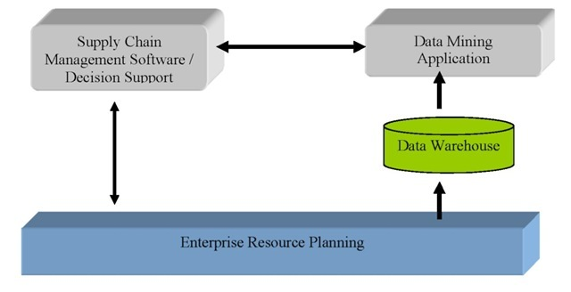

“Source: <http://www.weberlogistics.com/blog/california-logistics-blog/key-performance-indicator>”

KPIs are routinely used as a piece of business intelligence structures to evaluate the progress of various estimations against business goals. They have ended up being astoundingly notable for operational examination since they give an energetic and visual comprehension into quantifiable targets. KPIs are versatile business estimations that present an affiliation's status and examples toward achieving predefined destinations in clear and straightforward organize. After a generation system or part association describes its philosophy and goals, KPIs can be portrayed to measure its empowering toward those objectives. KPIs are getting the chance to be fundamental segments of generation organize execution organization programming, balanced scorecards, and logical dashboards. [6]

The limitations in not being able to implement the KPIs make the proposed system to show the inventory system to an extraordinary degree versatile and applicable in various store arrange circumstances and particular endeavors. Since they rely upon the SCM model and use a regulated estimations they can be used as a piece of various business organizations. On the other hand, datamining models configuration engages by and large basic and brisk customization and extensibility. For example, existing KPI parts can be easily reused normally, and simply required things can be added to locales and pages. In like manner, predictive analysis one of the concept of data mining can be best suitable for the supply chain organizations needs like a predicting the future customer demand. And a future forecast matrix can be easily created as shown in my below implementations. [7]

In, the below decision tree has been created considering the data set of demand forecasting of orders. This clearly explains the function of “Predictive Analysis” a data mining concept.

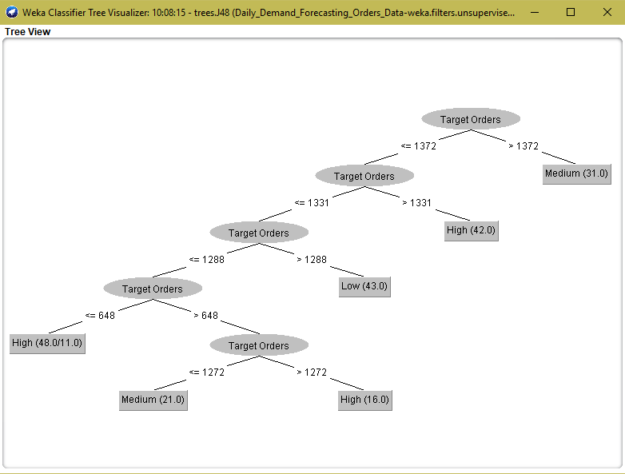

The decision tree has been considered for all the attributes with nominal and numerical values. Also, this decision tree has been generated using the “visualize tree” option in the Weka, which is the predictive analysis model created by J48 tree (C4.5 algorithm). It clearly shows that the Target Orders between, high, medium and low order demands. Order Demands is a nominal value and target orders is the numerical value and it plays a key role in the generation of this decision tree. Also, the range of target orders has been cleared classified using the supervised learning algorithm. Finally, the target orders classification with left of the decision tree has more nodes compared to the right branch and has made a deeper visualization of the order demands which makes the users capability to easily predict the data of demand. [3]

In this diagram I’ve represented the neural network a multi-layered perceptron approach function created using the data mining tool Weka. This has been created using the demand forecast data set and it clearly shows the classification of data between the input parameters considered providing the order demands as the output parameter. The middle layers are the hidden layers created using the datamining algorithm in a neural network perceptron. [7]

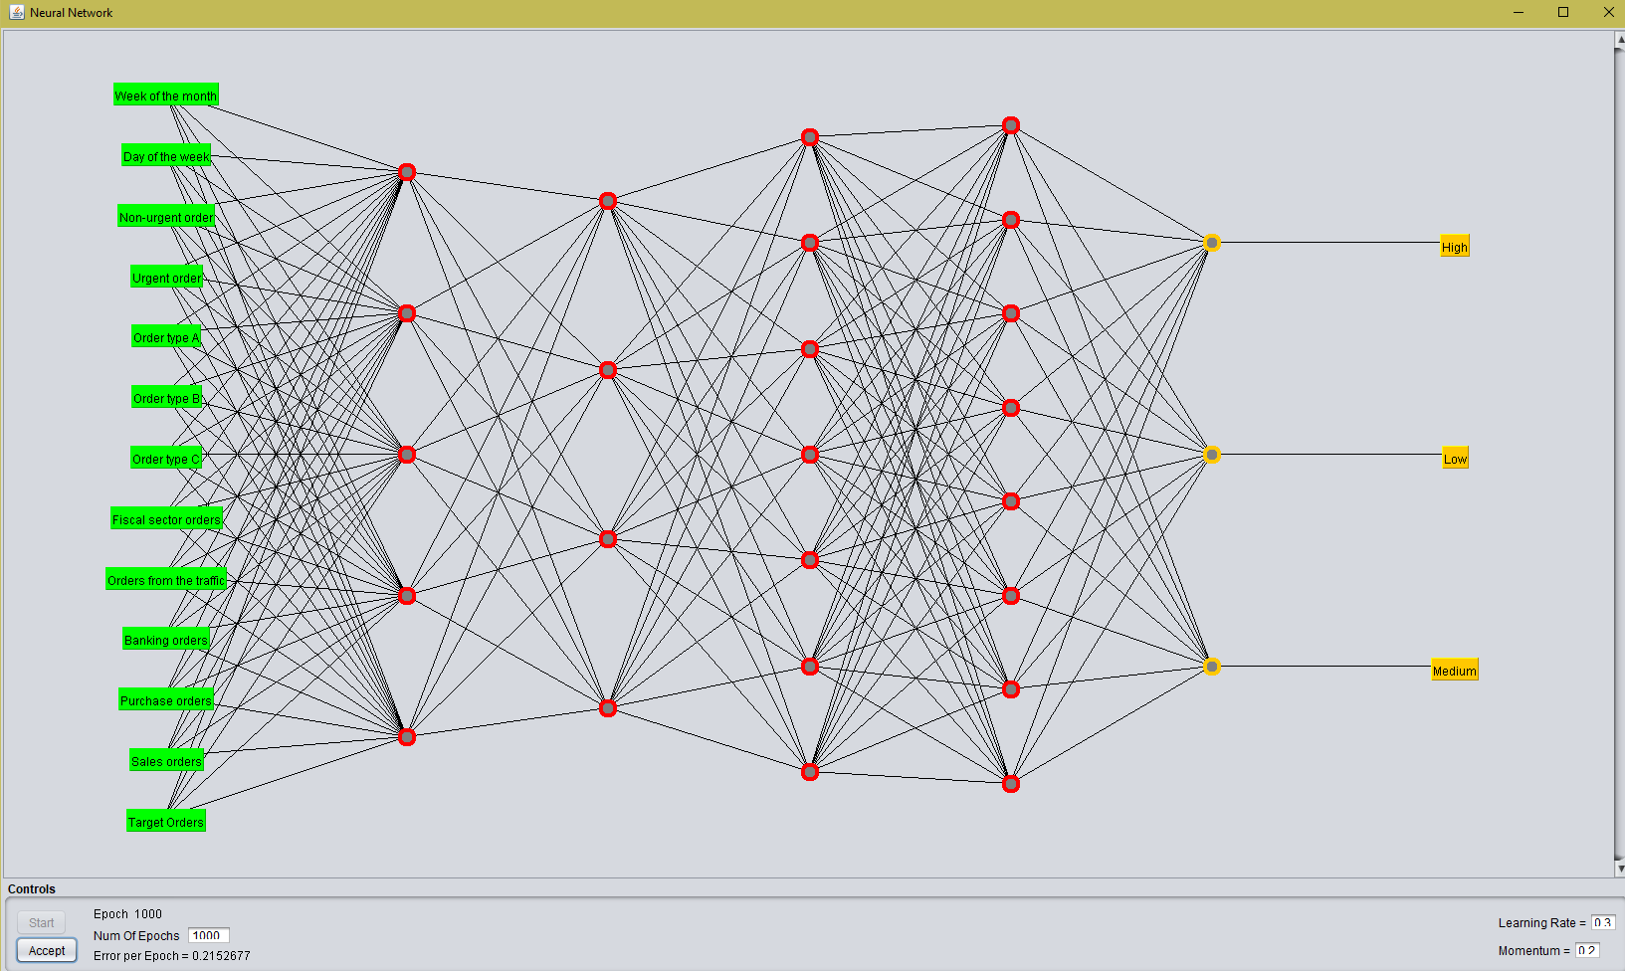

The below given gif images are created to demonstrate how a neural network classifies the unstructured output data using the multi-layered perceptron algorithm concept in data mining. You can visualize them by clicking on the image. [3] “Source: <https://playground.tensorflow.org>”





# Conclusion

So, as per the research made the datamining concepts determine the key performance indicators like “Demand Forecasting” in a supply chain management organization. It has been clearly shown that the decision tree algorithm and the neural network created using multi-layered perceptron algorithm will help the users to easily predict and analyze the stock and inventory data of an organization. It also helps to easily understand the flow between the nominal values like order demand and remaining factors like target orders which are numerical values.

References

1. Hyatt, P. (2016, December 02). The 5 Essential stages in developing a successful supply chain.

SME, S. (April 2, 2017). *Supply Chain Management.*

2. SCM Resources | Supply Chain Resource Cooperative | NC State University. (n.d.). Retrieved from <https://scm.ncsu.edu/scm-articles/article/category/articles/scm-resources>

3. Daniel Smilkov and Shan Carter. (n.d.). Tensor flow? Neural Network Playground. Retrieved from <http://playground.tensorflow.org>

4. Supply Chain and Logistics KPIs: Some Basic Principles Explained. (n.d.). Retrieved from <https://www.logisticsbureau.com/kpi-key-performance-indicator>

5. Anderson, C. (n.d.). 6 Essential Logistics Key Performance Indicator (KPIs). Retrieved from <http://www.weberlogistics.com/blog/california-logistics-blog/key-performance-indicator>

6. Data Mining for Supply Chain Management in Complex Networks. (n.d.). Retrieved from <http://what-when-how.com/information-science-and-technology/data-mining-for-supply-chain-management-in-complex-networks/>

7. Proactive Supply Chain Performance Management with Predictive Analytics. (2014, October 15). Retrieved from <https://www.hindawi.com/journals/tswj/2014/528917/>